Experiment1.3

Student Name: Himanshu UID: 20BCS7944
Branch: CSE Section: 905/A
Semester: 6 Date of Performance: 27/02/2023
Subject Name: IOT Lab Subject Code: 20CSP-358

1) Aim:

Demonstration of Autodesk Tinker cad Simulation Platform.

2) Objective:

Learn about IoT based simulations.

Testing the model in IoT based simulation platform.

3) Apparatus / Simulator used:
Tinker Cad – Web Application
Fedora 37 – Operating System

4) Theory:
Tinker cad also allows you to do programming using blocks. You can download / copy-paste the generated code later into Arduino IDE to program the real Arduino board, rather than having to write it from scratch.
Create a new personal account on Tinker cad website (you can also use your Google account to log in). Then select Circuits on the left pane, and click Create new Circuit.

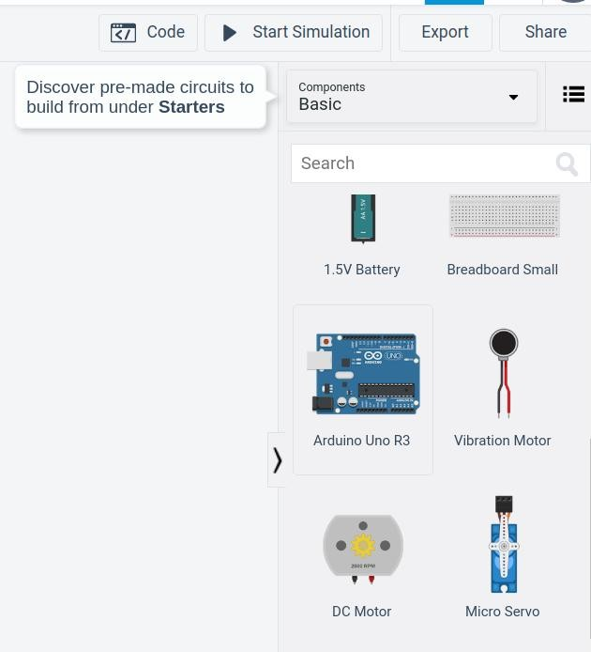

5) Code:

Void setup(){ pinMode(LED_BUILTIN, OUTPUT);
}
void loop(){ digitalWrite(LED_BUILTIN, HIGH);
delay(1000); // Wait for 1000 millisecond(s) digitalWrite(LED_BUILTIN, LOW); delay(1000); // Wait for 1000 millisecond(s)
}

6) Output:

